PACIFIC BLUE LENSES

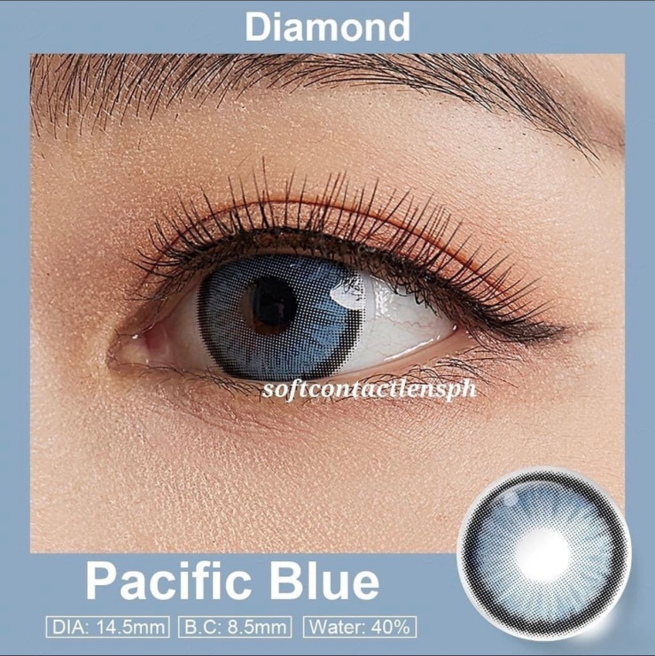

**DIA: 14.5mm**

**B.C: 8.5mm**

**WATER: 40%**

Allure Gray contact lenses are a type of colored contact lenses that offer a gray color option. These lenses are designed to enhance or change the natural eye color, providing a unique and captivating appearance. The gray shade of these lenses can range from a subtle and natural-looking gray to a more intense and dramatic gray, depending on the desired effect. Like other colored contact lenses, Allure Gray lenses are typically made from soft and breathable materials such as silicone hydro gel. These materials ensure comfort and allow for proper oxygen flow to the eyes. It is important to note that contact lenses, including Allure Gray ones, should be prescribed and fitted by a qualified eye care professional. They will assess your eye health, provide a proper fitting, and guide you on the safe and appropriate use of these lenses based on your individual needs and eye condition. Proper care and maintenance of Allure Gray contact lenses are essential to ensure their longevity and your eye health. Follow the cleaning and storage instructions provided by the manufacturer or your eye care professional. Additionally, adhere to the recommended wearing schedule and replace the lenses as directed to avoid any potential eye complications. Always consult with an eye care professional before purchasing and using Allure Gray contact lenses to ensure a safe and comfortable experience. They can provide personalized advice and guidance based on your specific requirements.